Ornaments as indicators of Social change before and after European contact at Kiwulan, Northeastern Taiwan

Li-Ying Wang

13 August, 2019

Text of abstract

# Introduction

The direct impacts of European colonialism on indigenous communities in East Asia were much less pronounced than island Southeast Asia and Oceania. Direct European colonial rule throughout East Asia was rare and limited, and the question of long-lasting indirect impacts on local indigenous communities remains largely unanswered. Understanding the indirect effects of colonialism are important for detecting colonial impacts on indigenous peoples in the periphery of colonial control (Torrence and Clarke, 2000; Trabert, 2017). In many parts of the world, the introduction of foreign trade goods by colonial traders into local indigenous societies caused substantial transformations of indigenous economic, cultural, and socio-political systems (Dietler, 1997; Junker, 1993; Mitchell, 2000; Silliman, 2005). Studying the consumption of foreign goods can improve our understanding of the negotiations between colonized and colonizer, and the resistance and accommodations of indigenous people through their daily cultural practices (Dietler, 2015, 2005; Given, 2004; Mullins, 2011; Rubertone, 2000; Scaramelli and Scaramelli, 2005; Silliman, 2001; Torrence, 2000; Torrence and Clarke, 2000; Voss, 2005).

Prior to contact with the Europeans in the early 17th century, Taiwan had been involved in both regional and long-distance East and Southeast Asian trade systems since the tenth century, and encountered large waves of Han Chinese immigration after 17th century when Taiwan was incorporated into the territories of Qing Dynasty of China (Andrade, 2007, ch. 11; Liu and Wang, 2017). The exchange network in northern Taiwan was influenced by long-distance trade between Fuzhou or Quanzhou in China and Ryukyu in Japan since the 15th century due to its location on shipping routes (Chen, 2005). This intensified in the 17th century with the arrival of the Europeans and their trade goods (Wang and Liu, 2007).

Taiwan became part of global trade systems during the early 17th century due to western European expansions that connected Europe and Asia. Despite the colonization of Taiwan by the Spanish and Dutch from 1624 to 1662, there has been little discussion of the archaeology of indigenous responses to the European colonization. Berrocal et al. (2018) examined both archaeological and historical records of Heping Dao in northern Taiwan. This was the location of the colony of San Salvador founded by the Spanish in 1626 and taken over by the Dutch in 1642. Berrocal et al. uncovered parts of the foundation of a Spanish church and a European cemetery that indicate the evidence of European occupation. These remains indicate a direct impact on the local indigenous populations through their modification of the local landscape. In contrast to Heping Dao, Yilan in Northeastern Taiwan is physically isolated and there are no traces of European settlement. This makes Yilan an especially unique location for exploring indirect colonial effects on local indigenous settlements because of isolation. The rugged Hsuehshan Range to the west and Central Range to the south of the Yilan Plain that made it not easily accessible to the European colonists and the colonial control was weaker compared to other parts of this region (Andrade, 2007; Kang, 2012). Yilan, also called “Kavalan” by local indigenous people, is an alluvial plain circumscribed by the Pacific and mountains on the sides. Rivers and seas provide the way for the interaction between local indigenous settlements and further afield communities, such as the Basai in northern Taiwan and Han Chinese. Kavalan people offered rice, deer hides, and gold in exchange for beads, metal tools or ornaments, ironwares, porcelains, and textiles with outside traders (Chen, 2005; Hsieh, 2009; Li and Wu, 2006).

mountains isolated Yilan by land, the sea provided a way through which indigenous people in Yilan could interact with groups elsewhere, such as indigenous groups, distant traders such as the Han people of China, and Europeans. Large-scale and frequent trading activities brought a wide variety of objects into indigenous communities in Yilan. indigenous people of Yilan established their own exchange network that has been described as part of an “inter-insular trade” system (Chen, 2005, p. 12) to refer to small-scale regional trade between China and Taiwan on an irregular basis. One of the most commonly traded types of object in this region were personal ornaments such as glass and stone beads. These are one of the most abundant types of foreign goods found at the settlement sites in this region (Chen, 2007; Li and Chiu, 2014; National Musuem of Taiwan History, 2005). Personal adornments in the archaeological record are useful as social signal of an individual’s status (Joyce, 2005; Scaramelli and Scaramelli, 2005). For example, the consumption of stone beads in Southeast Asia during Iron Age is often associated with increasing social stratification or socio-political complexity (Bellina, 2014; Carter, 2016; Francis, 2002; Kenoyer, 2000; Theunissen et al., 2000).

In this paper, I explore archaeological evidence from Yilan spanning from the late Iron Age to the historical period to address the question of whether indirect colonial influences on the indigenous populations can be detected. I focus on the ornaments recovered from the archaeological excavations at Kiwulan (1400-1900 AD), a large Iron Age settlement in northeastern Taiwan (Chen, 2007). Northeastern Taiwan provides a good example to explore the indirect colonial impacts on indigenous societies by comparing archaeological evidence from different episodes of culture contact (cf. Lape, 2003). I will describe the variety and cultural context of trade ornaments in this region, and examine the potential of ornaments to inform on social changes relating to trade with colonial groups. I hypothesize that there was a greater diversity of ornaments types and materials at Kiwulan after European contact due to participation in a larger scale exchange network. I also predict that after European contact there will be new patterns in the spatial distributions of ornaments at Kiwulan that indicate increasing social inequality. I hypothesize that after 1662 when European contact declined and Chinese contact became the dominant international tradition partner, there was a decline in the use and discard of ornaments at Kiwulan due to overall population declines and acculturation in the Chinese community. To test the hypothesis of a greater diversity of ornaments types and materials at Kiwulan after European contact, and a lesser diversity after Chinese contact, I compare frequencies of ornament types between different time periods. To test the prediction that after European contact were new spatial patterns in the distributions of ornaments at Kiwulan, I use kernel density and point pattern analyses.

# Cultural context of ornaments in Yilan, northeastern Taiwan

Historical documents from the Spanish and Dutch in the early 17th century provide some information about the social life and culture of indigenous people in Northern Taiwan when the Europeans arrived. The Spanish founded Fort San Salvador at Keelung in 1626 and Fort San Domingo in 1629 at Tamsui, and sent missionaries to local indigenous settlements in this region for religious purposes (Blussé and Everts, 2000, p. 343). A report by Dominican priest Fr. Jacinto Esquivel in 1632 mentioned that the Taparri, an indigenous tribe from northern Taiwan, usually used cuentas (agate beads) in exchange for necessities with other indigenous groups. This form of exchange was widespread and even the Spanish soldiers learned to use agate as bargaining chips for gambling (Li and Wu, 2006, pp. 132–149). Esquivel also recorded how indigenous people viewed agate pieces as prestige goods in their culture. An indigenous man who wanted to get married had to pay agate beads to the parents of his future wife. Also, agate or golden beads could be used to resolve conflicts in their daily lives (Li and Wu, 2006, p. 151). Other records mention that the female shamans (majuorbol) in the tribe would use agate beads as magical items in ritual practice for body healing (Borao, 2009, pp. 122–151). Records of an indigenous funeral process document the use of agate beads in ritual contexts, with more agate beads, pottery, and cloth placed into the graves of more influential people to indicate a family’s higher prestige (Li and Wu, 2006, p. 153). These historical accounts indicate that agate beads or golden beads were already treated as prestige goods before the arrival of the Europeans. These were likely introduced earlier from Chinese traders.

In 1642, the Dutch VOC defeated the Spanish and took over their forts in northern Taiwan. They introduced a feudal system in an attempt to control the indigenous communities by asking indigenous leaders to attend an annual ceremony for demonstrating their loyalty (Andrade, 2007, ch. 9; Kang, 2016, ch. 4). The Dutch provided beads and other goods based on the demands of Indigenous people to secure alliances in the annual ceremony or during traveling (Kang, 2016, ch. 6). Thus, I assume that the Dutch feudal system resulted in an increase in the amount and diversity of ornaments in northeastern indigenous communities during this period.

Chinese historical records from 1829, 1837, and 1852 during the Qing dynasty [1616-1911] contain some notes on the purposes of ornaments from Yilan (Chen, 1963, pp. 228, 308; Ke, 1993, pp. 11, 126; Yao, 1996, p. 77). According to those records, indigenous people in Yilan wore ornaments in ceremonial contexts to display their wealth and status. Among those ornaments, golden fish-shaped necklaces made of copper threads had high value due to its delicacy and the materials invested in production. These were usually possessed by wealthy people. Other people wore agate beads or glass beads on their head or neck to participate in ceremonies. In 1895, at the beginning of Japanese colonization, a field survey for plains indigenous groups reported that golden necklaces were not used in Yilan at that time, but elderly people still used beads (Ino, 1996, pp. 227–232).

Recent ethnographic research with the living members of the Kavalan tribe describes how agate beads were used in divination practices, called “subli”, by female shamans (Liu, 2008, pp. 133–134). Interview records mention agate beads as valuable objects that are usually passed down from mother to daughter as heirlooms in shaman families, without knowing the exact origin. When not in use, beads were often hidden in safe places, such as on the roof beams. Modern ethnographic research shows that agate beads were not only used as decoration, but also played an important role in divination, consistent with observations from the European colonial period. Despite most Kavalan people today not knowing the specific origin of their agate beads, the high value of beads is still indicated in oral history and by their scarcity. In sum, we find multiple sources describing how local Indigenous people used ornaments in cultural contexts that represents some social roles or high status. However, compared to the European contact period, there are fewer mentions of beads in Chinese contact period and the descriptions are limited to clothing, but generally confirm the role of beads as status markers.

# Excavations at Kiwulan in northeastern Taiwan

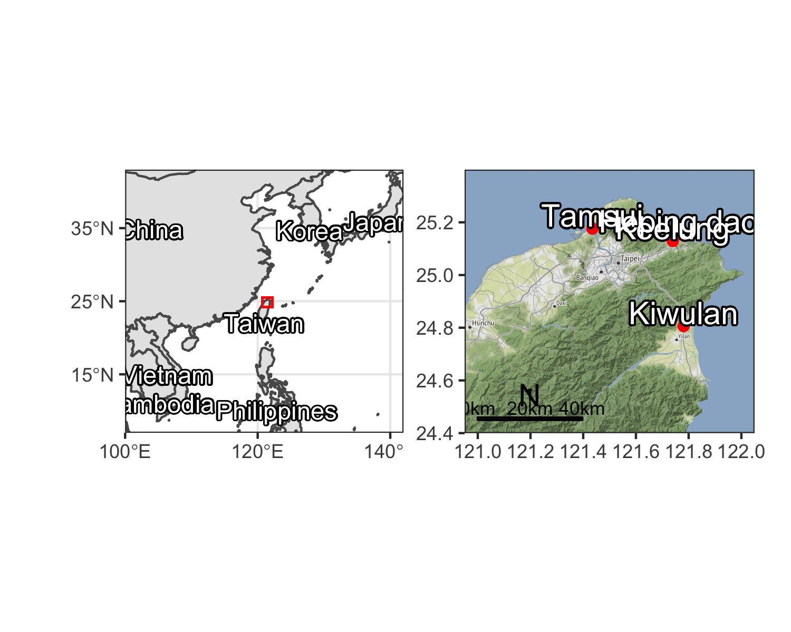

Figure 1: Map showing the location of Kiwulan, and other places in northern Taiwan named in the text

Figure 2: Map showing the largest section of excavation areas at Kiwulan, and the distribution of forty squares sampled in this paper presented in red with square ID number. Each square is 4 x 4 m

Figure 2: Map showing the largest section of excavation areas at Kiwulan, and the distribution of forty squares sampled in this paper presented in red with square ID number. Each square is 4 x 4 m

Kiwulan (Figure 1) is located at northern Yilan and was a rescue archaeology project that carried out from 2001 to 2004 in advance of water diversion project and construction of a road bridge. The total area includes eight open area sections of 262 excavation squares (4 m by 4 m) reaching 3,814 m2 in total (Chen, 2007). The archaeological evidence includes a large amount of artifacts, burials, middens, post holes, wooden pillars, and stone structures, all of which indicates it was a settlement. Most ornaments were found in situ while digging and some were collected through screens with 2 mm and 1.5 mm mesh. The ornaments studied in this paper were found from 40 adjacent squares in the largest open area, located in the middle part of the excavation, see Figure 2. They were sampled because those units were stratigraphically intact with the least disturbance by modern construction activity, compared to excavation squares on the periphery of the site.

The chronology of Kiwulan can be divided into two phases represented by a Lower Layer Culture (700 - 1200 AD) and a Upper Layer Culture (1400 - 1900 AD) with a sterile layer in between. This chronology is based on the stratigraphy and a series of 32 radiocarbon dates (Chen, 2007). This paper focuses on the Upper Layer Culture spanning from the late Iron Age to the historical period starting from the 17th century with European contact in Taiwan.

Previous researchers divided the Upper Layer Culture component into six layers spanning from the 14th century to the 19th century with hundred year intervals according to the radiocarbon dates, excavation depth, and types of diagnostic porcelains such as blue and white porcelains (Hsieh, 2009; Wang, 2011). The layers were assigned numbers from 1 to 6 where L1 corresponds to the youngest layer and L6, the bottom layer, refers to the oldest layer. However, because the specific methods of assigning layers to a time period was not documented in detail for the previous chronology, I reexamined the excavation records to produce a new chronology for the sampled squares. For each sampled square I separated excavation units into three episodes of time: pre-European contact period (L5 and L6), European contact period (L4), and Chinese contact period (L2 and L1).

I identify the start of European contact at Kiwulan at 1632, when the local villages were attacked by the Spanish who took revenge on an incident happened earlier that year (Borao, 2001, p. 163). Later in 1647, the Dutch attacked the indigenous villages and forced them to accept colonial rules and economic demands by paying annual tribute (Andrade, 2007). According to Dutch census reports in 1650, Kiwulan was the largest indigenous settlement in the plain, with a population of 840 adults (Nakamura, 1938, p. 12). In the archaeological record, the approximate indicators of the start of European contact at Kiwulan are the appearance of An-ping jars and stonewares (martavans/martaban) that were largely introduced to Taiwan during the early 17th century. They are frequently found in European shipwrecks from this period for transporting water, wine or other fluids on the long voyages. The jar shapes found at Kiwulan are typical of those found elsewhere in V.O.C sites occupied during the 17th century (Berrocal et al., 2018, p. 917; Cort, 2017, p. 282; Grave and McNiven, 2013; Ketel, 2011; Klose and Schrire, 2018, p. 131). I used the presence and absence of An-ping jars and stonewares, together with the radiocarbon dates, to identify excavation units associated with the pre-European and post-European periods.

European colonization ended in 1662 when they were defeated by the kingdom of Tungning founded by Koxinga from China. Later in 1683, the Qing dynasty ruled over Taiwan and a large wave of Han Chinese migrated to Yilan during the late 18th century. The archaeological signature of the Chinese contact period at Kiwulan is the large amount and varieties of Chinese porcelains, clay stoves, and a few opium pipe-bowls that were identified as items commonly used in the daily life of Chinese and the use of bricks and tiles for architectural buildings (Hsieh, 2009). Also, the description of the Chinese migration to Yilan can be seen from official Chinese records written in the early 19th century (Chen, 1963; Ke, 1993).

# The ornaments

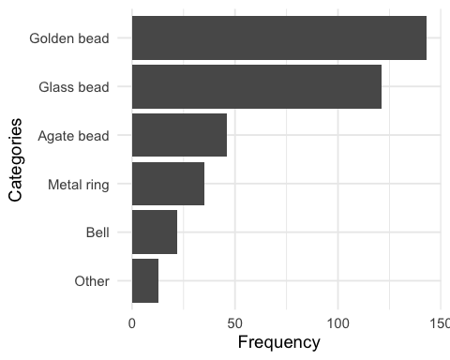

Figure 3: Frequency of the major class of ornaments at Kiwulan

Table 1: Ornament subtype frequencies at Kiwulan

|  |  |  |  |  |
| --- | --- | --- | --- | --- |
| Categories | Type | Before European Contact | European Contact | Chinese Contact |
| Agate bead | hexagonal | 6 | 17 | 5 |
| Agate bead | waxy oval | 0 | 4 | 0 |
| Agate bead | small oval | 3 | 3 | 0 |
| Agate bead | globular | 0 | 1 | 0 |
| Agate bead | pentagonal | 0 | 1 | 0 |
| Agate bead | big oval | 0 | 0 | 1 |
| Agate bead | long bicone | 0 | 0 | 1 |
| Agate bead | octagonal | 0 | 0 | 1 |
| Bell | large | 3 | 8 | 3 |
| Bell | plain small | 0 | 4 | 1 |
| Bell | thin small | 0 | 1 | 1 |
| Glass bead | small bead | 60 | 37 | 1 |
| Glass bead | medium bead | 8 | 15 | 0 |
| Golden bead | NA | 48 | 93 | 2 |
| Metal ring | wide small | 1 | 9 | 1 |
| Metal ring | thin large | 4 | 5 | 2 |
| Metal ring | wide large | 0 | 5 | 0 |
| Metal ring | overlapped | 0 | 2 | 0 |
| Metal ring | braid | 0 | 1 | 0 |
| Metal ring | entwined | 1 | 1 | 0 |
| Metal ring | flat | 0 | 1 | 0 |
| Metal ring | large thick string | 0 | 1 | 0 |
| Metal ring | small thin string | 0 | 1 | 0 |



Figure 4: Subtypes of ornament in each major class. A: agate beads, B: bells, C: glass beads and golden beads, D: metal rings. Photographs are presented in the same order as those subtypes in the table but from left to right instead. The photographs of B, C, D classes were from original excavation report (Chen 2007).

Ornaments from 40 sampling squares were excavated in-situ in different archaeological contexts, including 406 pieces from post-hole areas, 3173 pieces from 30 burials, and 27 pieces from middens. Burials unearthed a large amount of ornaments in the form of bead strings that consisted of hundreds to thousands of pieces. In this paper I focus on the post hole areas where 406 ornaments were recovered, which accounts for 46.5 % of the total number from the same context in the Upper Layer Culture at Kiwulan. Post hole areas represents domestic spaces suitable for testing for changes in the patterns of distribution relating to social organization. Figure 3 shows that the most common ornament is golden bead with the number of 143, followed by 121 glass beads, 46 agate beads, 35 metal rings, and 22 metal bells (see also Figure 4). The variety of subtype and their individual frequency are summarized in Table 1 in terms of three time episodes.

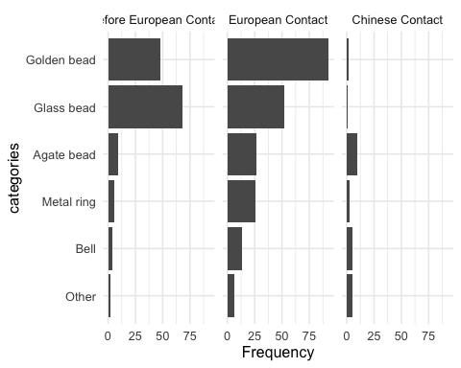

Figure 5: Frequency of the major ornament across different time periods.

# Results of hypothesis testing

## Changes in the frequencies of ornament types over time

Figure 5 shows the comparison of frequency for the major class of ornaments between different time periods at Kiwulan. The result of chi-square test for the number of ornaments (chi-square = 71.82, df = 8, p-value = 2.13632510^{-12}) shows that there is a non-random difference between the three time periods. It indicates that most ornament types were present before European contact. Ornament frequencies reached a peak during European contact and then dropped during the Chinese contact period, especially for golden beads. This trend can be also seen on other ornaments including agate beads, metal rings, and bells. However, glass beads show a different pattern that indicates a higher frequency in the pre-European contact, and then a decrease in the European contact period and a further decrease in the Chinese contact period.

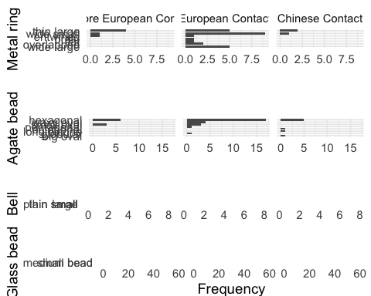

Figure 6: Frequency of ornament subtypes showing the changes in frequency across contact periods for metal rings, agate beads, bells, and glass beads.

The distribution of frequency for subtypes in each major class are presented in Figure 6. Spearman’s correlation test shows that there is no significant relationship between diversity of subtypes and sample size (S = 173.16, rho = 0.39, p-value = 0.2). This indicates that the increases in diversity can be explained by the effects of culture contact instead of effects of sample size. According to the frequency, agate beads and metal rings have greater quantity and variety of shapes compared to copper bell and glass beads during the European contact period. The greater varieties for agate beads and metal rings might indicate multiple origins due to participation in global trade networks stimulated by the Europeans. In contrast, copper bells and glass beads have less variety, but glass beads have a larger number because they were usually found in a cluster that indicates the original use as strings or necklaces. The common shape for copper bells is the large shape with a wide variety of human faces as a motif, while the common shape for glass beads is a bead with length less than 1 cm that are often identified as Indo-Pacific beads, the most common type that had been widespread in Southeast Asian sites since 300 BC (Francis, 2002).

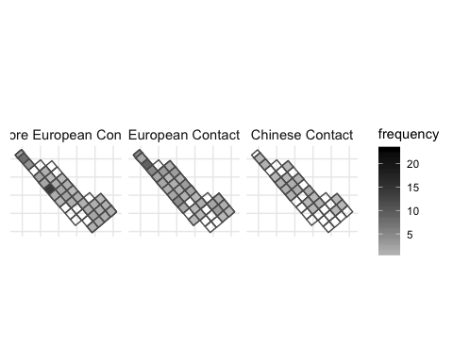

Figure 7: Spatial pattern of all class of ornament by time periods

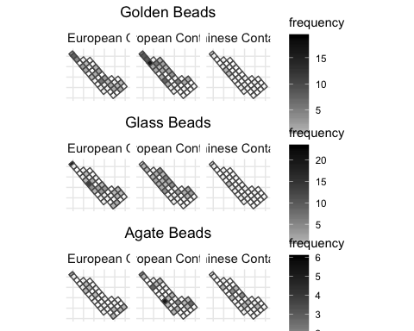

Figure 8: Spatial pattern for ornament class by time periods, only those types with more than 5 pieces are shown here

## Changes in patterns of the spatial distribution of ornament types

Figure 7 presents the spatial distribution of all ornaments from the research area for each time period. Before European contact, a greater amount of ornaments were found at the northern and middle parts of the research area. During the European contact period, ornaments were more widespread, with some clusters on the northern part. During the Chinese contact period the distribution is more even again. Figure 8 presents the distribution for the major ornament classes individually, some clusters across the area can be observed during the European contact, such as golden beads and agate beads. However, there seems to be no clear consistent pattern across those different ornaments. Each class shows its own pattern where the squares with higher number of ornaments distributed separately and independently. For example, the cluster of golden beads was found at the northern part, while the cluster of agate beads was found in the middle part. In contrast, there are multiple clusters of metal rings that are distributed separately across the research area. Copper bells were usually found individually and seem randomly distributed across the area. In the Chinese Contact period, both the amount and density of different classes of ornaments decreased.

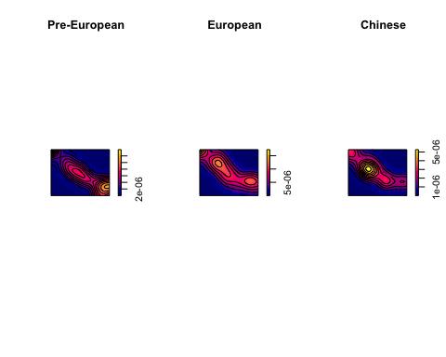

Figure 9: Kernal density map for ornaments by periods

## Point pattern analysis of ornament distribution

I used point pattern analysis to examine whether the distribution of ornaments was uneven in non-random ways that could reflect changes in social inequality. Point pattern analysis is a way to assess whether the distribution of sites or artifacts represent some “hotspots” produced by non-random processes, implying the influence of social processes (Bevan and Lake, 2016; Ducke, 2015). Hotspots in the pattern of ornaments could indicate changes in social organization due to culture contact. To explore ornament distributions I used the intensity approach that focuses on the average density of points across space. During excavation, ornament locations were only recorded to the square (4 x 4 m). To prepare the location data for point pattern analysis, I assigned each ornament to a random coordinate pair located in square it was recovered from. The next step was to subset the ornaments into three groups for three time periods. Finally I computed the kernel densities for each time period for comparison.

Kernel density estimations (KDE) estimate the probability of the density of ornaments across space by creating a continuous, smooth density surface across space. Here we use KDE to visualize core areas of ornaments and surrounding neighborhoods (Bonnier et al., 2019; Cortegoso et al., 2016). Density values of artifacts per square meter were calculated for each cell.

The results show that there is one major core area during the pre-European contact period, multiple core areas during European contact period, and a single core during the Chinese contact period (Figure 9). Those maps present three consistent sub-regions with a core area that shifts over time. The distribution might indicate different social groups who possessed more ornaments. The multiple groups during European contact period might reflect more unequal consumption of ornaments across the site, relative to other periods. However, the generation of core areas might be biased due to small sample size, for example, a few ornaments found at one single square during the Chinese period could create an obvious hot spot. To further evaluate the pattern, we test the hypothesis that the distribution of ornaments is not randomly distributed to determine if social processes might explain ornament distributions.

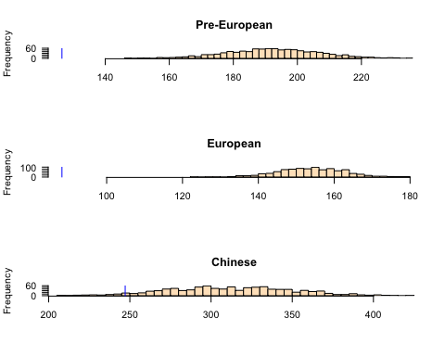

Figure 10: Histogram of simulated ANN values with the blue line indicating the observed value

To test this hypothesis about the randomness of spatial locations, I used a Monte Carlo method to simulate average nearest-neighbor distances (ANN). Our null hypothesis is that the distribution of ornaments is consistent with a completely random process. We simulated the locations of ornaments across the space 1000 times for each time period. The observed data was compared to the random patterns generated by simulated processes to determine if our data are randomly distributed or not. Figure 10 shows the distributions of the ANN distances calculated on 1000 simulations of ornament locations. The results show that 100% of the simulated values are much greater than our observed ANN value during the European contact period, which means the ornaments have non-random clustered distributions. A similar, but less extreme, result is also observed during the pre-European period. The observed distribution of ornaments is more similar to the random distributions during the Chinese contact period, with about one third of the simulated values are greater than our observed ANN value. This testing reveals that the clustered distributions of ornaments during the pre-European and European contact periods might reflect the presence of different social groups. Moreover, the clustering of ornaments during the European contact period is highly non-random, potentially indicating that some of the social changes leading to a concentration of power to control the distribution of ornaments at Kiwulan.

# Discussion

The results show there was a greater diversity of ornaments types and materials at Kiwulan during European contact. This might result from the large scale exchange network that stimulated the circulation of different ornament classes. However, the frequency of overall ornaments and each subtype declines significantly during the Chinese contact period. This may be due to a smaller scale of trading network, the overall decline of the indigenous population in Yilan, and adopting the mortuary practices of Han Chinese. Since the end of the 18th century, many indigenous people moved southwards to Hualien due to population pressure caused by Han Chinese immigrants (Chen, 2007). According to Chinese census reports in 1821 and Japanese field surveys in 1895, the Kiwulan population was less than 100 (Ino, 1898; Yao, 1996).

Spatial patterns of ornaments shows that their distribution was clustered during the pre-European and European contact period. Hypothesis testing for spatial patterns indicates that these clusters are non-random, and are most highly concentrated during the European contact period. Because ethnographic evidence indications that trade ornaments were prestige goods in prehistoric Northeastern Taiwan, this spatial clustering may indicate that a degree of social inequality was present before European contact and then it was reinforced and amplified during the European contact period. In addition, there was a burial dated to 17th century unearthed 60 golden beads above the average of 2-3 pieces in the pre-European period, further indicating increasing social inequality (Chen, 2007; Cheng, 2008).

How might these results fit into a bigger picture of social change at periphery of colonial systems? We may get some insight into the general pathways that led to social inequality in northeastern Taiwan by considering how people have achieved and maintained power in a wide variety of societies (Ames, 2010; Bowles et al., 2010; Drennan et al., 2010; Feinman, 2000). For example, the corporate/network model proposed by Feinman (2000) expands traditional hierarchical complexity to provide a comparative basis for distinct strategies for power. In the network mode, inequality develops when individuals accumulate wealth through their individual networks and people use their wealth to attract factions, control resources, and monopolize trade networks. In contrast, the corporate mode stresses shared power across different groups and sectors, integrative ceremonies and rituals, and large cooperative labor tasks (Feinman, 2000; Siegel, 1999).

We may consider that Yilan social organization went from corporate mode in the pre-European contact period, then transitioned into network mode during the European colonial contact period, then back to corporate mode in the Chinese contact period. The small number of ornaments, and less concentrated distribution during the pre-European period is consistent with shared power and wealth of the corporate mode. The long-distance trade network introduced by the Europeans resulted in the appearance of a network mode due to competition among ambitious individuals for prestige, wealth, or power through collecting trade goods (Brumfiel, 1994; Clark and Blake, 1994). Because of the weak direct control from the European colonizers in northeastern Taiwan, it implies that local leaders might have flexibility to manipulate European colonial image, expand personal power, and monopolize the high-value trade goods (Kang, 2012). During the Chinese contact period, the decreasing frequency and diversity of ornaments show a decline in the production, use and discard of ornaments at Kiwulan. This reflects the smaller scale of exchange networks, with limited sources of ornaments, and limited opportunities for individuals accumulate wealth.

# Conclusion

Examination of the indirect influence of colonialism can reveal how peripheral areas were influenced by the colonial activities or involved in the colonial economy centered in the major European colonies (Trabert, 2017). Kiwulan in Northeastern Taiwan is an important case study as an East Asian location that was relatively isolated and peripheral, and yet connected by regional and global trade networks. Kiwulan can provide valuable insights into the discussion of the influence of indirect colonial contacts. The frequency and spatial distribution of body ornaments at Kiwulan present three distinct patterns during different culture contact periods. The greater amount and diversity of ornament types during the European contact period reflects international exchanges in a colonial context. Those ornaments may carry an exotic and powerful image that signals wealth and trading connections for the inhabitants of Kiwulan. These symbolic values may have stimulated more competition between aggrandizing individuals for prestige and wealth accumulation at Kiwulan, which might have resulted in an increase in social inequality.

This study demonstrates that foreign ornaments can be a proxy to detect indirect colonial influence on local indigenous populations. Ornaments can give insights into the amplification of social inequality stimulated by European colonization. It also shows the agency of indigenous people to incorporate ornaments into their social system. Future work could extend this approach to studies of other trade goods such as ceramics. We have introduced here the corporate/network model for understanding the dynamics of social inequality at Kiwulan, and future tests of this should include analysis of pottery production and standardization, and mortuary practices.

# Acknowledgements

##### pagebreak

# References

Ames, K.M., 2010. On the evolution of the human capacity for inequality and/or egalitarianism, in: Feinman, G., Price, T.D. (Eds.), Pathways to Power: New Perspectives on the Emergence of Social Inequality. Springer, New York, pp. 15–44.

Andrade, T., 2007. How Taiwan became chinese : Dutch, spanish, and han colonization in the seventeenth century. Columbia University Press, New York.

Bellina, B., 2014. Maritime silk roads’ ornament industries: Socio-political practices and cultural transfers in the south china sea. Cambridge Archaeological Journal 24, 345–377.

Berrocal, M.C., Herrero, E.S., Moret, M.G., González, A.U., Pérez, M.T., Rodrı'guez, S.C., Chevalier, A., Valentin, F., Tsang, C.-h., 2018. A comprised archaeological history of taiwan through the long-term record of heping dao, keelung. International Journal of Historical Archaeology 22, 905–940.

Bevan, A., Lake, M., 2016. Intensities, interactions, and uncertainties: Some new approaches to archaeological distributions, in: Bevan, A., Lake, M. (Eds.), Computational Approaches to Archaeological Spaces. Routledge, pp. 27–52.

Blussé, L., Everts, N., 2000. (FEII) the formosan encounter. Notes on formosa’s aboriginal society, a selection of documents from dutch archival sources. Volume ii: 1636-1645. Shung Ye Museum of Formosan Aborigines, Taipei, Taipei.

Bonnier, A., Finné, M., Weiberg, E., 2019. Examining land-use through gis-based kernel density estimation: A re-evaluation of legacy data from the berbati-limnes survey. Journal of Field Archaeology 44, 70–83.

Borao, H., J. E., 2001. (SIT, pp. 1-343). Spaniards in taiwan, vol. I (1582–1641). SMC Publishing, Taipei.

Borao, J.E., 2009. The spanish experience in Taiwan, 1626-1642: The baroque ending of a renaissance endeavor. Hong Kong University Press, Hong Kong.

Bowles, S., Smith, E., Mulder, M., 2010. The emergence and persistence of inequality in premodern societies. Current anthropology 51, 7–17.

Brumfiel, E.M., 1994. Factional competition and political development in the new world: An introduction, in: Brumfiel, E.M., Fox, J. (Eds.), Factional Competition and Political Development in the New World. Cambridge: Cambridge University Press, pp. 3–13.

Carter, A.K., 2016. The production and exchange of glass and stone beads in southeast asia from 500 bce to the early second millennium ce: An assessment of the work of peter francis in light of recent research. Archaeological Research in Asia 6, 16–29.

Chen, S., 1963. Kavalan ting zhi [kavalen culture history], taiwan wen xian cong kan di 106 zhong [taiwan literature series: 106]. Economic Research Office, Bank ofTaiwan, Taipei.

Chen, T.-j., 2005. Ji long shan yu dan shui yang : Dong ya hai yu yu tai wan zao qi yan jiu, 1400-1700 [mount keelung and tai she ocean: A study of east asian seas and the hisotry of Taiwan from 1400 to 1700]. Lian jing, Taipei.

Chen, Y.-p., 2007. Qi wu lan yi zhi qiang jiu fa jue bao gao [ report on the archaeological excavations at ki-wu-lan site]. Lanyang museum, Yilan, Taiwan.

Cheng, C.-F., 2008. Qi wu lan yi zhi yu she nei yi zhi chu tu bo li zhu de xiang guan yan jiu [studies of glass beads excavated from kivulan and shenei site, taiwan] (Master’s thesis).

Clark, J.E., Blake, M., 1994. The power of prestige: Competitive generosity and the emergence of rank societies in lowland mesoamerica. Factional competition and political development in the New World 17–30.

Cort, L.A., 2017. Container jars from the maenam noi kilns, thailand use and reuse along maritime trade routes in asia. Bulletin de l’École française d’Extrême-Orient 103, 267–296.

Cortegoso, V., Barberena, R., Durán, V., Lucero, G., 2016. Geographic vectors of human mobility in the andes (34–36° s): Comparative analysis of ‘minor’obsidian sources. Quaternary International 422, 81–92.

Dietler, M., 2015. Archaeologies of colonialism: Consumption, entanglement, and violence in ancient mediterranean france. Univ of California Press.

Dietler, M., 2005. The archaeology of colonization and the colonization of archaeology: Theoretical challenges from an ancient mediterranean colonial encounter, in: Stein, G. (Ed.), The Archaeology of Colonial Encounters: Comparative Perspectives. NM: Sch. Am. Res. Press, Santa Fe, pp. 33–68.

Dietler, M., 1997. The iron age in mediterranean france: Colonial encounters, entanglements, and transformations. Journal of World Prehistory 11, 269–358.

Drennan, R.D., Peterson, C.E., Fox, J.R., 2010. Degrees and kinds of inequality, in: Pathways to Power. Springer, pp. 45–76.

Ducke, B., 2015. Spatial cluster detection in archaeology: Current theory and practice, in: Barcelo, J.A., Bogdanovic, I. (Eds.), Mathematics and Archaeology. CRC Press Boca Raton, Barcelona, Spain, pp. 352–368.

Feinman, G.M., 2000. Corporate/network: New perspectives on models of political action and the puebloan southwest. Social Theory in Archaeology, University of Utah Press, Salt Lake City 31–51.

Francis, P., 2002. Asia’s maritime bead trade: 300 bc to the present. University of Hawaii Press.

Given, M., 2004. The archaeology of the colonized. Routledge, London; New York.

Grave, P., McNiven, I.J., 2013. Geochemical provenience of 16th–19th century ce asian ceramics from torres strait, northeast australia. Journal of Archaeological Science 40, 4538–4551.

Hsieh, E., 2009. Yi lan qi wu lan yi zhi chu tu wai lai tao ci qi zhi xiang guan yan jiu [the study of imported ceramics excavated at the ki-wu-lan site, i-lan] (Master’s thesis).

Ino, K., 1996. Ping pu zu diao cha lu hang :Yi neng jia ju (tai wan tong xin) xuan ji [field investigation trips at plains indigenous peoples: Ino kanori (taiwan letters)]. Yuan Liou, Taipei.

Ino, K., 1898. Yilan homen ni oke ru no hei ho zoku minoru sa [field survey for the plains indigenous people in yilan]. Journal of the Anthropological Society of Tokyo 3, 345–354.

Joyce, R.A., 2005. Archaeology of the body. Annual Review of Anthropology 34, 139–158.

Junker, L.L., 1993. Craft goods specialization and prestige goods exchange in philippine chiefdoms of the fifteenth and sixteenth centuries. Asian Perspectives 1–35.

Kang, P., 2016. Colonial imagination and local variations: The dutch east india company and the formosan austronesians. Lian-jing.

Kang, P., 2012. He lan dong yin du gong si zhi xia de ga ma lan di qu te zhi [charateristics of kavalan under colonial rule of dutch east India companies], in: Hsu, M.-C., Li, S.-Y. (Eds.), Exploring Kiwulan: The Ninth Academic Conference of Yilan Study. Institute of Yilan County History, Yilan, pp. 291–317.

Ke, P., 1993. Kavalan zhi lue [record of kavalen]. Historical Records Committee of Taiwan Provincial Government, Nantou.

Kenoyer, J.M., 2000. Wealth and socioeconomic hierarchies of the indus valley civilization, in: Janet Richards, F.A., Mary Van Buren (Ed.), Order, Legitimacy and Wealth in Early States. Cambridge University Press Cambridge, pp. 90–112.

Ketel, C., 2011. Identification of export porcelains from early 17th century voc shipwrecks and the linkage to their cultural identification, in: Core, D. (Ed.), The 2011 Asia-Pacific Regional Conference on Underwater Cultural Heritage Proceedings. Manila, Philippines, pp. 1–14.

Klose, J., Schrire, C., 2018. Asian ceramic collections from voc sites at the cape, in: Schrire, C. (Ed.), Historical Archaeology in South Africa: Material Culture of the Dutch East India Company at the Cape. Taylor; Francis, pp. 101–141.

Lape, P.V., 2003. A highway and a crossroads: Island southeast asia and culture contact archaeology. Archaeology in Oceania 38, 102–109.

Li, C.-y., Chiu, S.-j., 2014. A report on excavations in the yi-lang agricultural vocational high school site, 2000-2008. Field Archaeology of Taiwan 17, 59–120.

Li, Y.-z., Wu, M.-z., 2006. Qing zai xi ban ya ren zai tai wan, 1626-1642 [the spanish in Taiwan]. Taiwan Historica, Nantou.

Liu, P.-c., 2008. Identity, gender and settlement: Ritual studies of changing kavalan. Taiwan Historica, Nantou: Council of Indigenous Peoples, Executive Yuan.

Liu, Y.-c., Wang, S.-C., 2017. Encountering the wider world before the transition to history: Chinese ceramics in proto-historic taiwan (tenth through sixteenth centuries), in: Cruz Berrocal, M., Tsang, C. (Eds.), Historical Archaeology of Early Modern Colonialism in Asia-Pacific: The Southwest Pacific and Oceanian Regions. University Press of Florida, Florida, Gainesville, pp. 270–312.

Mitchell, S., 2000. "Guns or barter" indigenous exchange networks and the mediation of conflict in post-caontact western arnhem land, in: Torrence, R., Clarke, A. (Eds.), The Archaeology of Difference : Negotiating Cross-Cultural Engagements in Oceania. Routledge, London; New York, pp. 182–214.

Mullins, P.R., 2011. The archaeology of consumption. Annual Review of Anthropology 40, 133–144.

Nakamura, 1938. Overgekomen brieven en papieren. [The dutch cencus record for indigenous peoples in taiwan]. Southern Anthropological Studies 4, 12.

National Musuem of Taiwan History, A. group in, 2005. Taiwan under dutch and spanish: A report of historical archaeological research in northern taiwan. National Musuem of Taiwan History, Taipei.

Rubertone, P.E., 2000. The historical archaeology of native americans. Annual Review of Anthropology 29, 425–446.

Scaramelli, F., Scaramelli, K.T. de, 2005. The roles of material culture in the colonization of the orinoco, venezuela. Journal of Social Archaeology 5, 135–168.

Siegel, P.E., 1999. Contested places and places of contest: The evolution of social power and ceremonial space in prehistoric Puerto Rico. Latin American Antiquity 209–238.

Silliman, S., 2001. Agency, practical politics and the archaeology of culture contact. Journal of social archaeology 1, 190–209.

Silliman, S.W., 2005. Culture contact or colonialism? Challenges in the archaeology of native North America. American Antiquity 55–74.

Theunissen, R., Grave, P., Bailey, G., 2000. Doubts on diffusion: Challenging the assumed indian origin of iron age agate and carnelian beads in southeast Asia. World archaeology 32, 84–105.

Torrence, R., 2000. Just another trader? An archaeological perspective on european barter with admiralty islandsers, Papua New Guinea, in: Torrence, R., Clarke, A. (Eds.), The Archaeology of Difference: Negotiating Cross-Cultural Engagements in Oceania. Routledge, London; New York, pp. 104–141.

Torrence, R., Clarke, A., 2000. Negotiating difference: Practice makes theory for contemporary archaeology in Oceania, in: Torrence, R., Clarke, A. (Eds.), The Archaeology of Difference : Negotiating Cross-Cultural Engagements in Oceania. Routledge, London; New York, pp. 1–31.

Trabert, S., 2017. Considering the indirect effects of colonialism: Example from a great plains middle ground. Journal of Anthropological Archaeology 48, 17–27.

Voss, B.L., 2005. From casta to californio: Social identity and the archaeology of culture contact. American Anthropologist 107, 461–474.

Wang, L.-Y., 2011. Yi lan qi wu lan yi zhi chu tu zhuang shi pin zhi xiang guan yan jiu [a research of ornaments excavated at ki-wu-lan site, i-lan] (Master’s thesis).

Wang, S.-C., Liu, Y.-C., 2007. Shi qi shi ji qian hou tai wan yan cao , yan dou yu bo li zhu shi de shu ru wang luo -yi ge xin de jiao huan jie duan [the import networks of tobacco, tobacco pipes, and glass bead ornaments into Taiwan circa the seventeenth century: A new phase of exchange]. Taida Journal of Art History 51–83.

Yao, ying, 1996. Dong cha ji lue [record of taiwan], taiwan wen xian cong kan di 007 zhong [taiwan literature series: 007]. Taiwan Historica, Nantou.

##### pagebreak

### Colophon

This report was generated on 2019-08-13 09:56:19 using the following computational environment and dependencies:

#> ─ Session info ──────────────────────────────────────────────────────────  
#> setting value   
#> version R version 3.6.0 (2019-04-26)  
#> os macOS Sierra 10.12.6   
#> system x86_64, darwin15.6.0   
#> ui X11   
#> language (EN)   
#> collate en_US.UTF-8   
#> ctype en_US.UTF-8   
#> tz America/Los_Angeles   
#> date 2019-08-13   
#>   
#> ─ Packages ──────────────────────────────────────────────────────────────  
#> package * version date lib source   
#> abind 1.4-5 2016-07-21 [2] CRAN (R 3.6.0)  
#> assertthat 0.2.1 2019-03-21 [2] CRAN (R 3.6.0)  
#> backports 1.1.4 2019-04-10 [2] CRAN (R 3.6.0)  
#> bookdown 0.11 2019-05-28 [2] CRAN (R 3.6.0)  
#> broom 0.5.2 2019-04-07 [2] CRAN (R 3.6.0)  
#> callr 3.2.0 2019-03-15 [2] CRAN (R 3.6.0)  
#> cellranger 1.1.0 2016-07-27 [2] CRAN (R 3.6.0)  
#> class 7.3-15 2019-01-01 [2] CRAN (R 3.6.0)  
#> classInt 0.3-3 2019-04-26 [2] CRAN (R 3.6.0)  
#> cli 1.1.0 2019-03-19 [2] CRAN (R 3.6.0)  
#> codetools 0.2-16 2018-12-24 [2] CRAN (R 3.6.0)  
#> colorspace 1.4-1 2019-03-18 [2] CRAN (R 3.6.0)  
#> cowplot * 0.9.4 2019-01-08 [2] CRAN (R 3.6.0)  
#> crayon 1.3.4 2017-09-16 [2] CRAN (R 3.6.0)  
#> DBI 1.0.0 2018-05-02 [2] CRAN (R 3.6.0)  
#> deldir 0.1-21 2019-06-15 [2] CRAN (R 3.6.0)  
#> desc 1.2.0 2018-05-01 [2] CRAN (R 3.6.0)  
#> devtools 2.0.2 2019-04-08 [2] CRAN (R 3.6.0)  
#> digest 0.6.19 2019-05-20 [2] CRAN (R 3.6.0)  
#> dplyr * 0.8.1 2019-05-14 [2] CRAN (R 3.6.0)  
#> e1071 1.7-2 2019-06-05 [2] CRAN (R 3.6.0)  
#> ellipsis 0.2.0 2019-06-20 [2] CRAN (R 3.6.0)  
#> evaluate 0.14 2019-05-28 [2] CRAN (R 3.6.0)  
#> forcats * 0.4.0 2019-02-17 [2] CRAN (R 3.6.0)  
#> foreign 0.8-71 2018-07-20 [2] CRAN (R 3.6.0)  
#> fs 1.3.1 2019-05-06 [2] CRAN (R 3.6.0)  
#> generics 0.0.2 2018-11-29 [2] CRAN (R 3.6.0)  
#> ggplot2 * 3.2.0 2019-06-16 [2] CRAN (R 3.6.0)  
#> glue 1.3.1 2019-03-12 [2] CRAN (R 3.6.0)  
#> goftest 1.1-1 2017-04-03 [2] CRAN (R 3.6.0)  
#> gtable 0.3.0 2019-03-25 [2] CRAN (R 3.6.0)  
#> haven 2.1.0 2019-02-19 [2] CRAN (R 3.6.0)  
#> here * 0.1 2017-05-28 [2] CRAN (R 3.6.0)  
#> highr 0.8 2019-03-20 [2] CRAN (R 3.6.0)  
#> hms 0.4.2 2018-03-10 [2] CRAN (R 3.6.0)  
#> htmltools 0.3.6 2017-04-28 [2] CRAN (R 3.6.0)  
#> httr 1.4.0 2018-12-11 [2] CRAN (R 3.6.0)  
#> jsonlite 1.6 2018-12-07 [2] CRAN (R 3.6.0)  
#> KernSmooth 2.23-15 2015-06-29 [2] CRAN (R 3.6.0)  
#> knitr 1.23 2019-05-18 [2] CRAN (R 3.6.0)  
#> labeling 0.3 2014-08-23 [2] CRAN (R 3.6.0)  
#> lattice 0.20-38 2018-11-04 [2] CRAN (R 3.6.0)  
#> lazyeval 0.2.2 2019-03-15 [2] CRAN (R 3.6.0)  
#> lubridate 1.7.4 2018-04-11 [2] CRAN (R 3.6.0)  
#> magrittr 1.5 2014-11-22 [2] CRAN (R 3.6.0)  
#> maptools * 0.9-5 2019-02-18 [2] CRAN (R 3.6.0)  
#> Matrix 1.2-17 2019-03-22 [2] CRAN (R 3.6.0)  
#> memoise 1.1.0 2017-04-21 [2] CRAN (R 3.6.0)  
#> mgcv 1.8-28 2019-03-21 [2] CRAN (R 3.6.0)  
#> modelr 0.1.4 2019-02-18 [2] CRAN (R 3.6.0)  
#> munsell 0.5.0 2018-06-12 [2] CRAN (R 3.6.0)  
#> nlme * 3.1-140 2019-05-12 [2] CRAN (R 3.6.0)  
#> pillar 1.4.1 2019-05-28 [2] CRAN (R 3.6.0)  
#> pkgbuild 1.0.3 2019-03-20 [2] CRAN (R 3.6.0)  
#> pkgconfig 2.0.2 2018-08-16 [2] CRAN (R 3.6.0)  
#> pkgload 1.0.2 2018-10-29 [2] CRAN (R 3.6.0)  
#> polyclip 1.10-0 2019-03-14 [2] CRAN (R 3.6.0)  
#> prettyunits 1.0.2 2015-07-13 [2] CRAN (R 3.6.0)  
#> processx 3.3.1 2019-05-08 [2] CRAN (R 3.6.0)  
#> ps 1.3.0 2018-12-21 [2] CRAN (R 3.6.0)  
#> purrr * 0.3.2 2019-03-15 [2] CRAN (R 3.6.0)  
#> R6 2.4.0 2019-02-14 [2] CRAN (R 3.6.0)  
#> raster * 2.9-5 2019-05-14 [2] CRAN (R 3.6.0)  
#> Rcpp 1.0.1 2019-03-17 [2] CRAN (R 3.6.0)  
#> readr * 1.3.1 2018-12-21 [2] CRAN (R 3.6.0)  
#> readxl 1.3.1 2019-03-13 [2] CRAN (R 3.6.0)  
#> remotes 2.1.0 2019-06-24 [2] CRAN (R 3.6.0)  
#> rlang 0.4.0 2019-06-25 [2] CRAN (R 3.6.0)  
#> rmarkdown 1.13 2019-05-22 [2] CRAN (R 3.6.0)  
#> rpart * 4.1-15 2019-04-12 [2] CRAN (R 3.6.0)  
#> rprojroot 1.3-2 2018-01-03 [2] CRAN (R 3.6.0)  
#> rstudioapi 0.10 2019-03-19 [2] CRAN (R 3.6.0)  
#> rvest 0.3.4 2019-05-15 [2] CRAN (R 3.6.0)  
#> scales 1.0.0 2018-08-09 [2] CRAN (R 3.6.0)  
#> sessioninfo 1.1.1 2018-11-05 [2] CRAN (R 3.6.0)  
#> sf * 0.7-4 2019-04-25 [2] CRAN (R 3.6.0)  
#> sp * 1.3-1 2018-06-05 [2] CRAN (R 3.6.0)  
#> spatstat * 1.60-1 2019-06-23 [2] CRAN (R 3.6.0)  
#> spatstat.data * 1.4-0 2018-10-04 [2] CRAN (R 3.6.0)  
#> spatstat.utils 1.13-0 2018-10-31 [2] CRAN (R 3.6.0)  
#> stringi 1.4.3 2019-03-12 [2] CRAN (R 3.6.0)  
#> stringr * 1.4.0 2019-02-10 [2] CRAN (R 3.6.0)  
#> tensor 1.5 2012-05-05 [2] CRAN (R 3.6.0)  
#> testthat 2.1.1 2019-04-23 [2] CRAN (R 3.6.0)  
#> tibble * 2.1.3 2019-06-06 [2] CRAN (R 3.6.0)  
#> tidyr * 0.8.3 2019-03-01 [2] CRAN (R 3.6.0)  
#> tidyselect 0.2.5 2018-10-11 [2] CRAN (R 3.6.0)  
#> tidyverse * 1.2.1 2017-11-14 [2] CRAN (R 3.6.0)  
#> units 0.6-3 2019-05-03 [2] CRAN (R 3.6.0)  
#> usethis 1.5.0 2019-04-07 [2] CRAN (R 3.6.0)  
#> withr 2.1.2 2018-03-15 [2] CRAN (R 3.6.0)  
#> xfun 0.8 2019-06-25 [2] CRAN (R 3.6.0)  
#> xml2 1.2.0 2018-01-24 [2] CRAN (R 3.6.0)  
#> yaml 2.2.0 2018-07-25 [2] CRAN (R 3.6.0)  
#>   
#> [1] /Users/EmilyWang/Desktop/School document/LW-Paper/kwl-ornaments-2019/renv/library/R-3.6/x86_64-apple-darwin15.6.0  
#> [2] /Library/Frameworks/R.framework/Versions/3.6/Resources/library

The current Git commit details are:

#> Local: master /Users/EmilyWang/Desktop/School document/LW-Paper/kwl-ornaments-2019  
#> Remote: master @ origin (https://github.com/LiYingWang/master.paper.git)  
#> Head: [9058b9a] 2019-08-13: Merge branch 'master' of https://github.com/LiYingWang/master.paper

Word count: 4575